Ideation Phase
Define the Problem Statements

Date | 20 February 2025
Team ID | LTVIP2026TMIDS41763
Project Name | ShopEZ:One-Stop Shop for Online Purchases
Maximum Marks | 2 Marks

Customer Problem Statement Template:
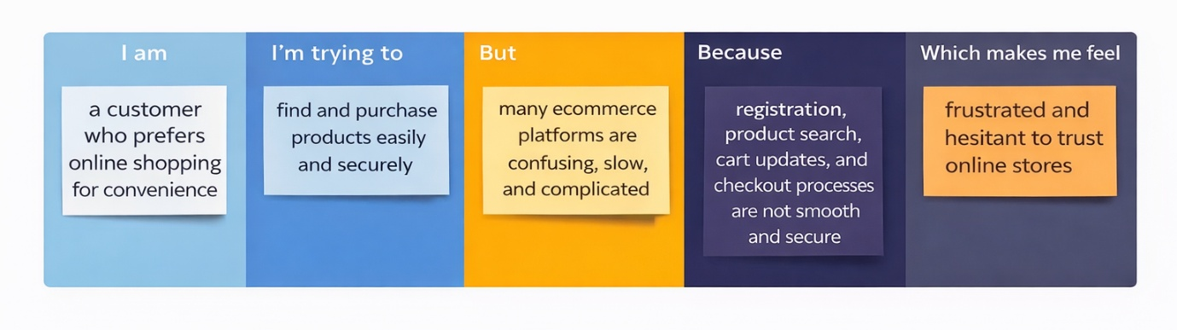
Reference: https://miro.com/templates/customer-problem-statement/
Problem Statement (PS) | I am (Customer) | I’m trying to | But | Because | Which makes me feel
PS-1 | a buyer | find and purchase products online | many ecommerce websites are confusing | navigation and search are not user-friendly | frustrated and discouraged
PS-2 | a buyer | complete checkout quickly | the payment process is complicated | multiple steps and unclear instructions | annoyed and impatient
PS-3 | a buyer | manage items in my cart | cart updates are slow or inconsistent | system does not update in real-time | confused and uncertain
PS-4 | a buyer | trust an online store | security information is unclear | lack of visible authentication and protection | insecure and hesitant
PS-5 | a buyer | search for specific products | search results are inaccurate | poor filtering and search algorithms | disappointed and stressed
PS-6 | a seller | list my products online | I don’t have an easy admin panel | product management tools are limited | restricted and overwhelmed
PS-7 | a seller | track my orders and sales | order tracking is not centralized | no proper dashboard system | disorganized and frustrated
PS-8 | a seller | manage inventory securely | stock updates are manual | lack of database integration | worried and inefficient

